SIX Stages of Internet growth:
The growth of internet can be divided into several stages as follows
- Experimental Networking :
- covers the early years of interne
- it has the provenance of a relatively small technical community.
- Eg: arpanet
- Discipline Specific Research:
- Grew out of the more general ARPAnet and began to build international on-line communities
For eg SCNET( computer science research network),HEPnet.
- General Research Networking
- was established to allow exchange of information and access to remote resources within the research and education community
- eg early NSFNET(national science foundation network),BITNET(Because It’s Time Network)
- Privatization and Commercialization
- Involves removing government subsidies to regional networks and dismantling (taking part) the barriers imposed by restrictive acceptable usage policies
Eg.present NSFNET
- Restricted public data networks for research and education
- provide and support advanced research and education networking services and capabilities for connection researchers, educators and students in universities,high schools ,research laboratories
- eg. National Research and Education Network (NREN) and HPCC( high performance computing and communication)
- National information Infrastructure
- is the ultimate goal.
- The objective is to extend networking everywhere ( ubiquitous) and enable new consumer appliocation
Eg Information Superhighway (I-way)

NSFNET: ARCHITECTURE AND COMPONENTS:
· National Science Foundation (NFS) has created five super computer centers for complex and wider range of scientific explorations in mid-1980s. Until then, supercomputers were limited to military researchers and other who can afford to buy.
· NSF wanted to make supercomputing resources widely available for academic research. And the logic is that the sharing of knowledge, databases, software, and results was required. So NSF initially tried to use the ARPANET, but this strategy failed because of the military bureaucracy and other staffing problems. So, NSF decided to build its own network, based on the ARPANET's IP technology.
· The NFSNER backbone is initially connected to five supercomputing networks with initial speed 56 kbps telephone leased lines. It was considered fast in 1985 but it is too slow according to modern standards.
· Since every university could not be connected directly to the center, need of access structure was realized and accordingly each campus joined the regional network that was connected to the closest center. With this architecture, any computer could communicate with any other by routing the traffic through its regional networks, where the process was reserved to reach the destination. This can be depicted in the three level hierarchical models as shown in the figure:
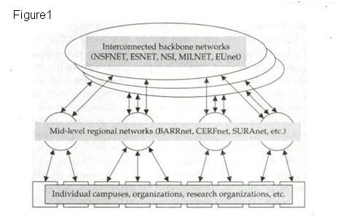
Figure1 shows the structure of the Internet hierarchy from national backbone to campus network.
· This abstraction is not completely accurate because it ignores commercial network providers, international networks, and interconnections that bypass the strict hierarchy.

· Water distribution systems may be useful analogy in understanding the technology and economics of the NSFNET program.
1. We can think of the data circuits as pipes that carry data rather than water.
2. The cost to an institution was generally a function of the size of the data pipe entering the campus.
3. The campuses installed plumbing and appliances such as computers, workstations and routers. And Service cost as an infrastructure cost such as classrooms, libraries and water fountains.
· But there is no extra charge for data use.
· The mid-level networks acted like cooperatives that distributed data from the national backbone to the campuses. They leased data pipes from the telephone companies, and added services and management. So each member could access the pipe and either consume or send data.
· Some funding was also provided by the federal government.
· This model was a huge success but became a victim of its own success and was no longer effective. One main reason for it was-the network's traffic increased until, eventually, the computer controlling the network and the telephone lines connecting them became saturated. The network was upgraded several times over the last decade to accommodate the increasing demand.
The NSFNET Backbone
· The NSFNET backbone service was the largest single government investment in the NSF-funded program. This backbone is important because almost all network users throughout the world pass information to or from member institutions interconnected to the U.S. NSFNET.
· The current NSFNET backbone service dated from 1986, when the network consisted of a small number of 56-Kbps links connecting six nationally funded supercomputer centers. In 1997, NSF issued a competitive solicitation for provision of a new, still faster network service.
· In 1988, the old network was replaced with faster telephone lines, called T-1 lines that had a capacity of 1.544 Mbps compared to the earlier 56 Kbps, with faster computers called routers to control the traffic.
· By the end of 1991, all NSFNET backbone sites were connected to the new ANS-provided T-3 backbone with 45 Mbps capacity. Initial 170 networks in July 1988 to over 38,000 and traffic of initial 195 million packets to over 15 terabytes. Discussions of electronic commerce were due to the economic factor. The cost to the NSF for transport of information across the network decreased.
· It fell from approximately $10 per megabyte in 1987 to less than $1.0 in 1989. At the end of 1993, the cost was 13 cents. These cost reduction occurred gradually over a six-year period. Cost reductions were due to new faster and more efficient hardware and software technologies.
Mid-Level Regional Networks
· Mid level Regional Networks are often referred to as regional networks, are one element of the three-tier NSFNET architecture.
· They provide a bridge between local organizations, such as campuses and libraries, and the federally funded NSFNET backbone service.
· The service of Mid Level Regional Networks tends to vary from sub state, statewide and multistate coverage.
State and Campus Networks
· State and campus networks link into regional networks.
· The mandate for state networks is to provide local connectivity and access to wider area services for state governments, K-12 schools, higher education, and research institutions.
· Campus networks include university and college campuses, research laboratories, private companies, and educational sites such as K-12 school districts.
· These are the most important components of the network hierarchy, as the investment in these infrastructures far exceeds that of the government's investments in the national and regional networks.

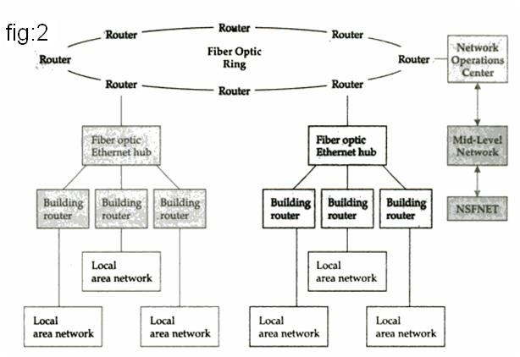
Fig2: Figure2 shows the Network hierarchy in campus network interconnecting multiple local area networks to the Internet

Internet Governance:
Internet governance is the development and application of shared principles, norms, rules, decision-making procedures, and programs that shape the evolution and use of the Internet

Internet Society:
The Internet is a collection of autonomous and interconnected networks that implement open protocols and standards. No person, government, or entity owns or controls the Internet. Instead, a volunteer organization called ISOC (Internet Society) controls the future of the Internet. It appoints a technical advisory group called the IAB (Internet Architecture Board) to evaluate and set standards.
The organizations and committees that oversee the Internet are charted in Figure I-7. These organizations are described next. In general, the IETF forms working groups to develop specifications, which are evaluated by the IESG in conjunction with the IAB (Internet Architecture Board). The Internet Society then publicizes the new standards. Web standards are promulgated by the W3C (World Wide Web Consortium) and other groups.
Internet Society (ISOC)

Internet Architecture Board (IAB)
Internet Engineering Steering Group
Internet Engineering Task Force (IETF)
(area directors,IETEF director,IAB liaison(connection) )

Area director
Area director
Area director

Figure internet governance hierarchy

- ISOC (Internet Society) The ISOC is a nongovernmental international organization to promote global cooperation and coordination for the Internet, and its internetworking technologies and applications. The ISOC approves appointments to the IAB from nominees submitted by the IETF Nominating Committee.
- IAB (Internet Architecture Board) The IAB is a technical advisory group of the ISOC (Internet Society). Its responsibilities are to appoint a new IETF chair and IESG candidates, serve as an appeal board, manage editorial content and publication (RFCs), and provide services to the Internet Society.
- IESG (Internet Engineering Steering Group) The IESG is chartered by ISOC to provide technical management of IETF activities and the Internet standards process. The IESG manages the IETF working groups and is directly responsible for the actions associated with entry into and movement along the Internet "standards track," including final approval of specifications as Internet standards.
- IRTF (Internet Research Task Force) The purpose of the IRTF is to create research groups that focus on Internet protocols, applications, architecture, and technology. The groups are small and long term, and are put together to promote the development of research collaboration and teamwork in exploring research issues. Participation is by individual contributors rather than by representatives of organizations. The IRSG manages the research groups and holds workshops that focus on the evolution of the Internet and discuss research priorities from an Internet perspective.

- IETF (Internet Engineering Task Force) The IETF is a large open international community of network designers, operators, vendors, and researchers concerned with the evolution of the Internet architecture and the smooth operation of the Internet. The actual technical work of the IETF is done in its working groups, which include Applications, Internet, Network Management, Operational Requirements, Routing, Security, Transport, and User Services. Working groups are managed by members of the IESG. The IAB provides architectural oversight

